**Project Design Phase-I**

**Solution Architecture**

|  |  |  |
| --- | --- | --- |
| **Team ID** | | PNT2022TMID23841 |
| **Project Name** | | **IoT based Safety Gadget for Child Safety, monitoring and notification** |
| **TEAM LEADER &TEAM MEMBERS** | 1. DHARANI N  2.ADITHYA V  3.DEEPIKA B  4.GOPIKA M |

**Solution Architecture:**

Solution architecture is a complex process – with many sub-processes – that bridges the gap between business problems and technology solutions. Its goals are to:

* Find the best tech solution to solve existing business problems.
* Describe the structure, characteristics, behavior, and other aspects of the software to project stakeholders.
* Define features, development phases, and solution requirements.
* Provide specifications according to which the solution is defined, managed, and delivered.

**Solution Architecture Diagram:**

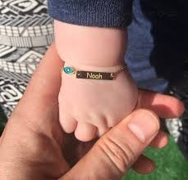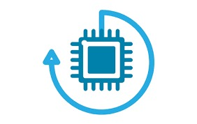

IOT DEVICE

USER

SHOES

ORNAMENTS

WEB UI

CLOUDANT DB

IBM PLATFORM

GEOFENCE